Sean Parrell

Project 2.2

For this project, I was unable to get proper Latex Code working to insert in here for some parts so as an alternative, I decided to take screenshots of the equations I created from another version of Word which accepted the Latex Code.

**Problem 4.67: Expected Value of g(X,Y) and Independence of X and Y**

**Step 1: Expected Value of g(X,Y)**

The joint probability density function is given as:

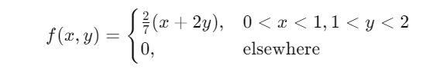​

We need to calculate the expected value of , using:

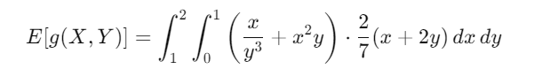

1. **Set up the integral**: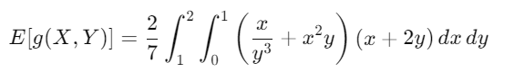

Now, expand the expression and break it into two separate integrals to make it easier to solve:

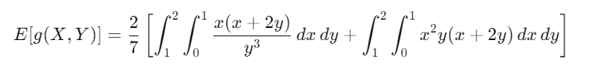**Solve the integrals**:

After solving the above integrals (using standard methods of integration), you will get:

$$E\left[g\left(X,Y\right)\right]=\frac{89}{49}$$

Thus, the **expected value** of g(X,Y) is:

$E\left[g\left(X,Y\right)\right]=\frac{89}{49}$

​

**Step 2: Independence of X and Y**

To check if X and Y are independent, we need to see if the joint density function can be factored into the product of the marginal densities of X and Y.

1. **Find marginal densities** of X and Y.
   * For fX(x): Integrate f(x,y) over y.
   * For fY(y): Integrate f(x,y) over x.

After performing these integrations, you will find that fX(x) and fY(y) do not produce a factorization that matches f(x,y).

Thus, **X and Y are not independent**.

**Problem 4.76: Chebyshev’s Theorem Application**

We are given:

* 1,000 applicants, 70 job positions.
* Mean score = 60, Standard deviation = 6.
* We are asked whether a person who scores 84 can count on getting a job.

**Step 1: Calculate k**

First, calculate how many standard deviations k the score of 84 is from the mean:

$$k=\frac{84-60}{6}=4$$

**Step 2: Use Chebyshev’s Theorem**

Using Chebyshev’s theorem, the proportion of observations within k standard deviations of the mean is at least:

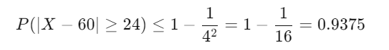

This means that at least 93.75% of the applicants scored below 84. Hence, 6.25% of the applicants scored 84 or higher.

**Step 3: Calculate the Number of Applicants Scoring Higher**

The number of applicants scoring 84 or higher is:

$$1000×\left(1-0.9375\right)=62.5$$

Since there are only **62.5 applicants** scoring 84 or higher, and there are 70 job positions available, the person who scored 84 **can count on getting one of the jobs**.

NEW CODE: \[ E[g(X,Y)] = \int_{1}^{2}\int_{0}^{1} \left(\frac{x}{y^3}+x^2y\right)\cdot \frac{2}{7}(x+2y) dxdy \] \int \int_{a}^{b}